Exercise: Replicative immortality
1) For memorization:
a) Which of the following characteristics can distinguish senescent cells from normal terminally differentiated cells:
- Cell flattening and increase in size
- Failure to re-enter the cell cycle in response to any growth factors
- Shortened telomeres
- Expression of a lysosomal β-galactosidase
- Decrease of heterochromatin and repressive histone marks
- A distinct senescence-associated secretory phenotype

2) Comprehension of concept (important):
a) Telomere erosion can either induce senescence or a "crisis". What determines these alternative fates?
b) How can you distinguish which of these two states premalignant cells have entered?
c) What mechanism kills premalignant cells during crisis?
d) How can tumor cells escape from crisis and become immortalized?
e) How do breakage-fusion-bridge cycles increase the aggressiveness of malignant cancer cells?

3) Application: Role of TGF-β induced senescence in breast cancer. In the exercise last week, we saw that autocrine TGF-β signaling in healthy mammary glands inhibits the proliferation of hormone receptor-positive cells to thereby prevent excessive duct tissue growth and side branching induced by estrogen and progesterone. To test TGF-β functions in mouse models of breast cancer, its activity was blocked by administering a C-terminally truncated mutant type II TGF-β receptor that cannot signal because it lacks the kinase domain, but which still binds ligand via the extracellular domain and thus acts as a “ligand trap”. Genetically, this construct functions as a “dominant negative” mutant by competing with wild-type receptors for ligand binding:
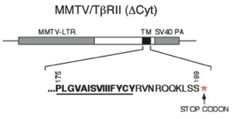
Truncated TβR2 (Δcyt)
(dominant negative)

As a model of human breast cancer, human mammary epithelial cells (HMECs) from breast resections were immortalized by hTERT overexpression (S. Lin et al. 2013 Mol Biol Cell). To test a role of autocrine TGF-β signaling in oncogene-induced senescence, the resulting cells were then sequentially transfected with dominant negative mutant type II receptor (DNRII) or with control vector, and with oncogenic H-RasG12V:
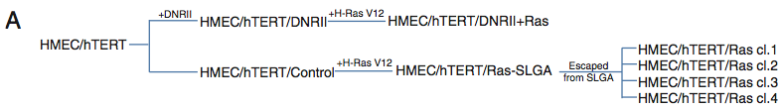

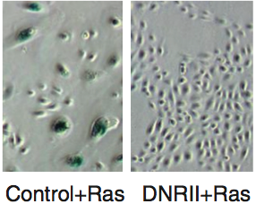
The authors found that DNRII inhibited the induction of acidic β-galactosidase (blue staining in panels shown to the left). Interestingly, after selection for anchorage-independent growth in soft agar, a few subclones escaped from a senescence-like growth arrest (SLGA) even in the absence of DNRII (top panel).

a) Based on these results, what mechanism could possibly explain how clones 1 to 4 escaped from senescence?
b) What Western blots or immunostainings would you perform on clones 1 to 4 to test your hypothesis?

4) Data interpretation: Mutant mice lacking the TERC subunit of telomerase unexpectedly showed no defects until after several generations of inbreeding between TERC-/- males and females. By contrast, after 3 to 6 generations of such inbreeding they became infertile, showing high rates of apoptosis in testis, combined with intestinal atrophy, and impaired bone marrow function:
TERC-/- phenotypes. a) Histological sections through WT or 6th generation TERC-/- intestines. b) Testes of WT versus TERC-/- males treated with BrdU (top) or after Terminal deoxynucleotidyl transferase (TdT) labelling of apoptotic cells (bottom).
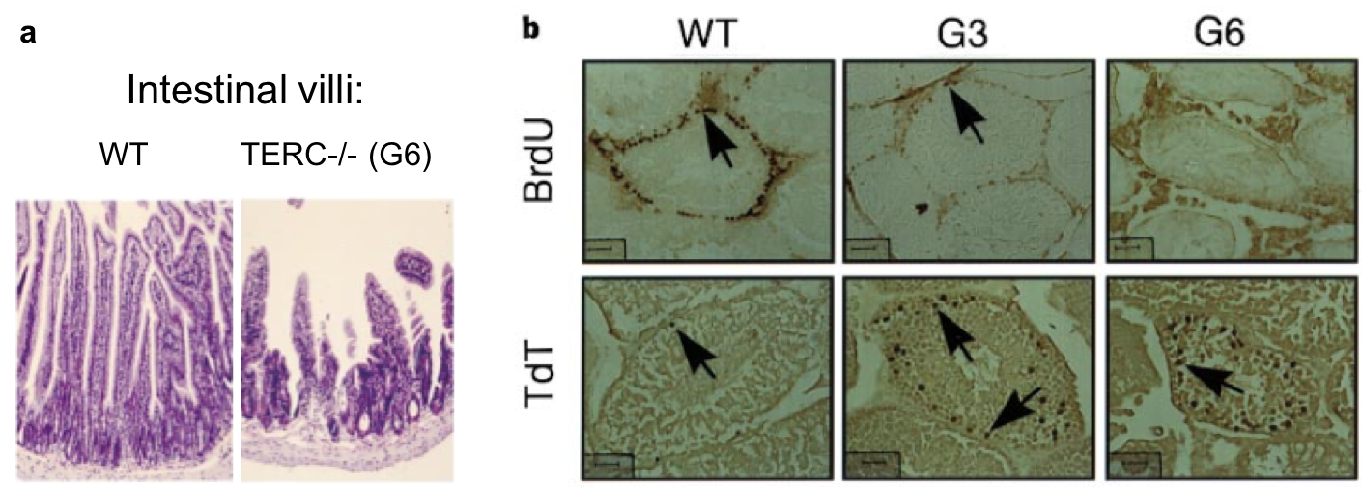
- What do tissues affected by the deletion of TERC have in common?
- Mice have longer telomeres than humans. What mechanism(s) could explain how mutant intestines became atrophied, and why only after TERC was lacking in the germline for several generations?
- Did the dead cells (stained by TdT labelling, black arrows) undergo replicative senescence prior to their death? Why or why not?

5) Data interpretation: To assess its role in breast cancer, an Id1 transgene (TRE::Id1) was introduced in H-RasG12V mouse mammary epithelial cells (MMECs) that were then grafted into mouse mammary glands to monitor tumor formation. In mammary glands of mice treated without the tetracycline analog doxycycline, MMEC grafts expressing only Id1 or H-RasV12 alone very rarely formed tumors compared to grafts expressing both transgenes (A-B). Moreover, tumors that received DOX to switch off the TRE::Id1 transgene stained positive for p16Ink4a and SA-βGal expression (C).
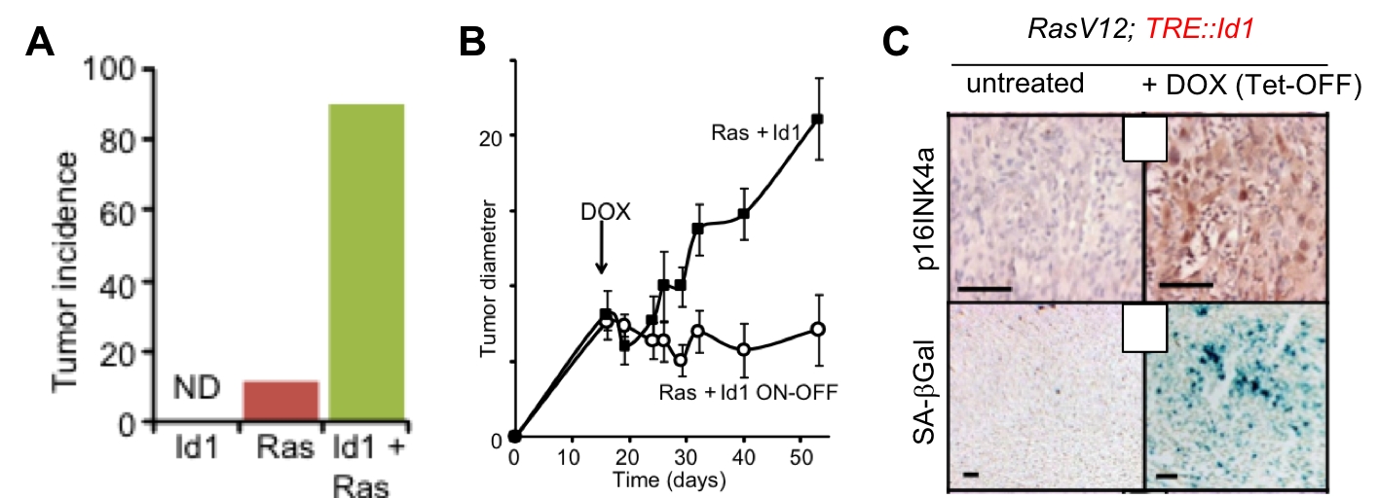
How would you explain that oncogenic Ras alone was unable to efficiently induce tumorigenesis?

